CONCLUSION:

Ultimately, sentiment analysis is not always accurate, but neither are we when trying to decode what someone means by their expressions or by any other communication means. Within social media monitoring, we need sentiment analysis as a starting point to understand general public sentiment in aggregate. From there, we can use the public’s general emotions to initiate campaigns based on their feedback.

Social media is perhaps the largest pool from which we can mine insights for public opinion and begin to gather informative data on the success or failure of our brand, products, or marketing campaigns in the eyes of the public.

Here, a simple yet powerful model using python has been built which precisely will analyse the mood of the person to a particular post he/she reads on the social media, the model will say about the person having positive, negative or neutral thoughts about that post and also, the results will be visualized through a bar and pie chart. Also, another model on Microsoft Excel has been developed where the comments of the users have been scraped and analysed their reviews on the particular product. The results are represented in the form of a dashboard which will show the output of the analysis. Initially, dataset of 50 comments is taken and analysed which shows accurate results, this can be extended to any number of comments in the datasets.

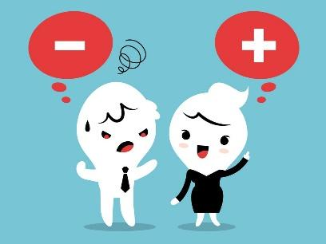

In sum, sentiment analysis helps in the interpretation of human behaviour towards any situation. This typically involves taking a piece of text, whether it’s a sentence, a comment or an entire document and returning a “score” that measures how positive, negative or neutral the text is.